2021-2022 Budget Hearing
April 26th, 2021
Village of Spencer Public Hearing

Roll Call – Kenneth Sutfin, Gilbert Knapp, Nicole O’Connell-Avery & Tim Goodrich
Public Hearing called to order by Ken at 7:01 PM.

MOTION to purchase cameras for the Park made by Gil, seconded by Tim. Passed unanimously by all.

MOTION to pass 2021-2022 Budget made by Tim, Seconded by Gil. Passed unanimously by all.
Annual Salaries will be in effect by June 1st, 2021.
Budget as follows:
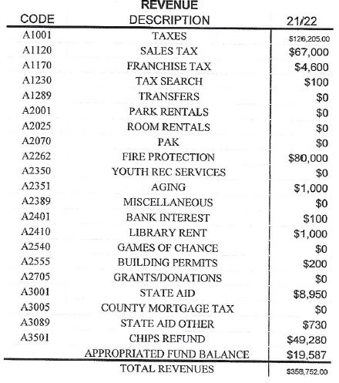
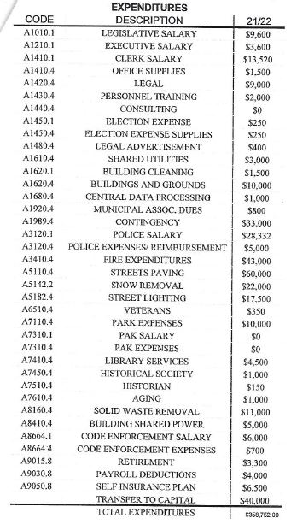

Public hearing adjourned at 7:15 PM, moved by Tim. Seconded by Gil.

